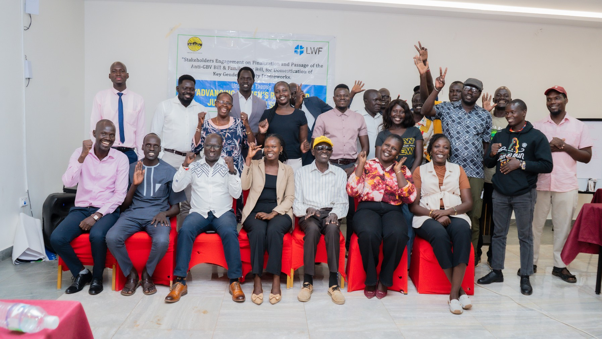
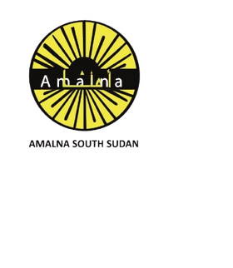
February 2026

Monthly Newsletter
A newsletter made by Amalna South Sudan

Welcome to Amalna South Sudan’s Monthly Newsletter!
February 2026

Greetings! We are excited to bring you the latest updates, stories, and insights from Amalna South Sudan. This newsletter is your window into our ongoing efforts to promote inclusive development, strengthen communities, and advocate for meaningful change across the country.
Each month, we highlight our projects, celebrate milestones, share voices from the field, and offer a glimpse into the impact of our work.

Through this platform, we aim to keep you informed, inspired, and connected to the journey of building a more just, equitable, and resilient South Sudan.

Thank you for being part of our community—together, we continue to transform challenges into opportunities and vision into action.

Monthly Newsletter February 2026

CCoonntteenntt IInnddeexx

About Amalna South Sudan ....................... 1 Quarter 1 Review Meeting with LWF 2-3
Public Hearing on FY25/26 Draft National Budget and Finance Bill 4
Joint CSO Lobby and Advocacy Meeting 5-6
Announcement for March Activities 7

Layout and Design
Santo Ochan Modi

Team/Contributors
Kaunda David Guya Joel
Santo Ochan Modi Peter Likambo Alex Amule Gordon Towongo

Executive Director
Luate Joseph


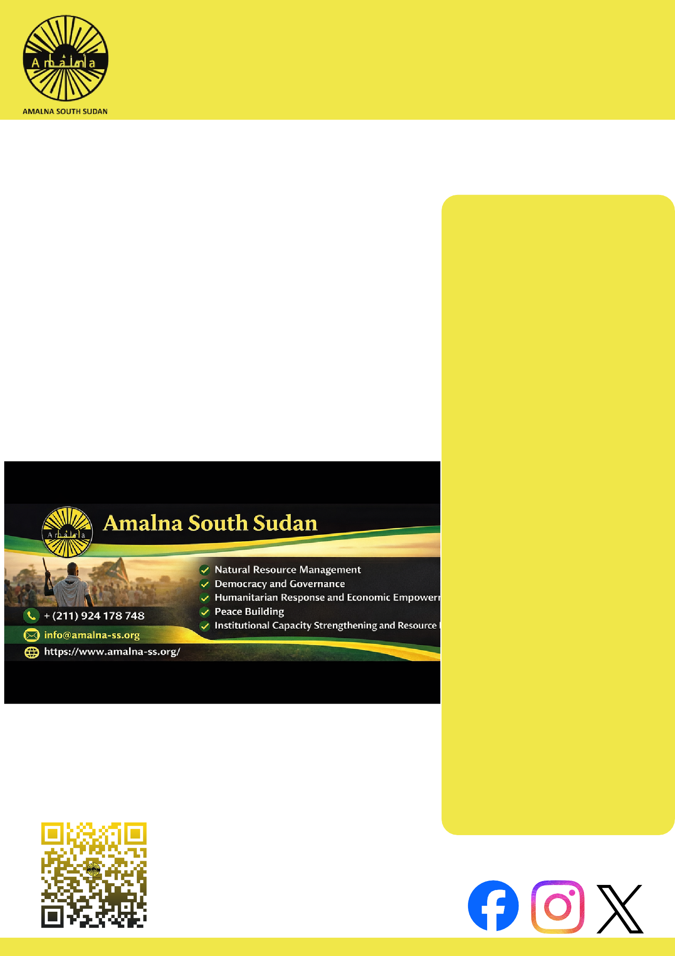

For More Information Contact
Munuki 3rd Class Residential Area, Plot No.49 Block A 111, Bilpham Road Juba,
Republic of South Sudan

scan to visit our Website to learn More
About Us

Our Thematic areas
Natural Resource Management Democracy and Governance Humanitarian Response
and Economic Empowerment Peace Building
Institutional Capacity Strengthening and Resource Mobilization

Our Vision
An informed citizenry and accountable leadership positively engaged in protecting human rights, democracy and development of South Sudan.
About Us
Monthly Newsletter February 2026
1


Our Mission
Promoting access to information, effective citizen participation, and accountable government and enabling people equitably enjoy their livelihood and wellbeing

Our Values
Transparency Accountability Teamwork Honesty Commitment Volunteerism Innovation Respect Integrity

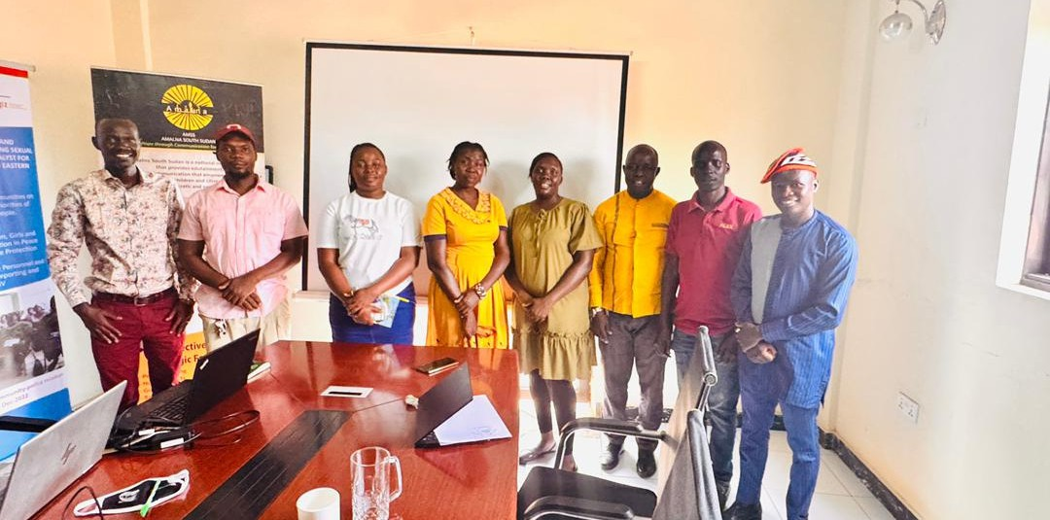
Juba, 6th February 2026 – AMALNA South Sudan has held a Quarter I Project Review Meeting with its donor, the Lutheran World Federation (LWF), to assess progress under the Advancing Gender Justice through Inclusive Legal Engagement (AGILE) Project and evaluate achievements toward the enactment of the Anti-GBV Bill and the Family Law Bill in South Sudan.
Monthly Newsletter February 2026
AMALNA SOUTH SUDAN HELD A QUARTER 1 REVIEW MEETING WITH ITS PARTNER LWF
Amalna South Sudan staffs and LWF staffs during the Quarter 1 Review Meeting

The review meeting examined implementation progress, beneficiary reach, performance indicators, financial accountability, and lessons learned during the first quarter. AMALNA presented updates on key activities, including joint civil society lobby and advocacy engagements and a high-level policy dialogue with Members of Parliament and other stakeholders.

During Quarter I, AMALNA convened a joint
CSO lobby and advocacy meeting that
2
engaged 31 participants, with strong representation of women and persons with disabilities. A high-level policy dialogue was also conducted, bringing together 40 participants, including MPs from five key Standing Specialized Committees of the Revitalized Transitional National Legislative Assembly (RTNLA).

According to the review findings, 95 percent of participants in both engagements were newly introduced to the detailed content of the Anti-GBV and Family Law Bills and reported improved understanding. Civil society actors were able to submit inputs into the bills, while MPs expressed increased readiness to support their passage once tabled. These engagements strengthened coordination among CSOs and generated critical parliamentary buy-in.

The impact of these efforts extends beyond institutional discussions. By improving lawmakers’ understanding and strengthening advocacy coordination, the project is helping to accelerate legal reforms that directly affect women, girls, and families across South Sudan.
Monthly Newsletter February 2026

The Anti-GBV Bill seeks to strengthen prevention and response mechanisms against gender-based violence, while the Family Law Bill aims to provide clearer legal protections in matters of marriage, divorce, child custody, and inheritance. Advancing these laws is expected to enhance protection of rights, promote justice, and contribute to social stability

The review also highlighted important institutional gains, including the recruitment of a MEAL Officer and Digital Officer, development of a comprehensive Monitoring, Evaluation, Accountability, and Learning (MEAL) framework, and establishment of a Complaints and Feedback Mechanism to ensure transparency and public accountability.
Despite operating within a challenging political and civic environment, AMALNA successfully delivered planned milestones and adapted through dialogue-based engagement and continuous stakeholder coordination.

Both AMALNA South Sudan and LWF reaffirmed their commitment to ensuring inclusive participation in the legislative process and advancing reforms that respond to the needs and voices of citizens. As the project moves into Quarter II, planned activities include further high-level dialogues, civil society engagements, media outreach, and public awareness campaigns to expand citizen participation and accelerate the enactment of the two critical bills.

3
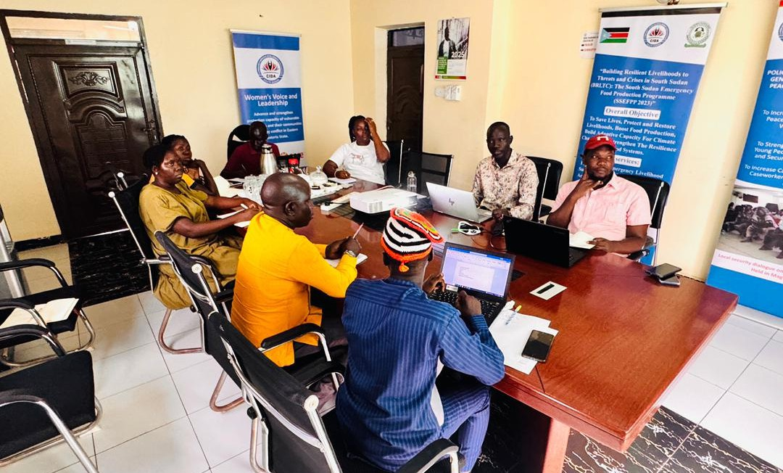

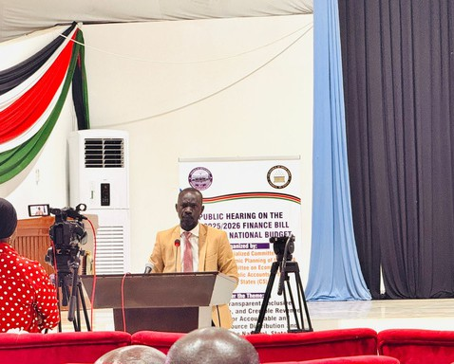
Monthly Newsletter February 2026

AMALNA SOUTH SUDAN PARTICIPATES IN PUBLIC HEARING ON FY 2025/2026 DRAFT NATIONAL BUDGET AND FINANCE BILL
During the session, stakeholders highlighted key economic challenges, including delayed salaries, high taxation, liquidity constraints, and the need for structural reforms and coordinated revenue management. Calls were also made to strengthen domestic revenue mobilization and ensure that public resources are directed toward critical services.

Mr. Kaunda David, Program Manager, Amalna South Sudan
Juba, South Sudan – AMALNA South Sudan participated in the Public Hearing on the FY 2025/2026 Draft National Budget and Finance Bill at the National Legislative Assembly in Juba, represented by its Program Manager, Mr.
Kaunda David.

The hearing, organized by the Standing Specialized Committee of Finance and Economic Planning, brought together government institutions, civil society, private sector actors, and development partners to deliberate on transparent and accountable revenue collection and equitable resource distribution.
The impact of AMALNA South Sudan’s engagement lies in amplifying citizens’ voices within national budget processes and promoting accountability in public finance management. By actively participating in the hearing, the organization contributed to ensuring that budget discussions reflect concerns related to service delivery, social protection, and inclusive governance. Such engagement helps to influence policy decisions that directly affect livelihoods, access to basic services, and economic stability for communities across the country.

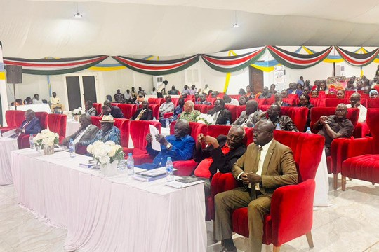
As Parliament prepares for the Second Reading of the Draft Budget, AMALNA South Sudan reaffirmed the critical role of civil society in strengthening transparency, accountability, and participatory governance to ensure that the national budget responds to the real needs of the population.
AMALNA South Sudan’s participation was guided by its objective to advocate for a people-centered and gender-responsive national budget that prioritizes the needs of
women, girls, and vulnerable communities. The organization emphasized the importance of allocating adequate resources to essential sectors such as health, education, protection services, and social welfare, particularly in a context of economic hardship and declining donor support in South Sudan.
4

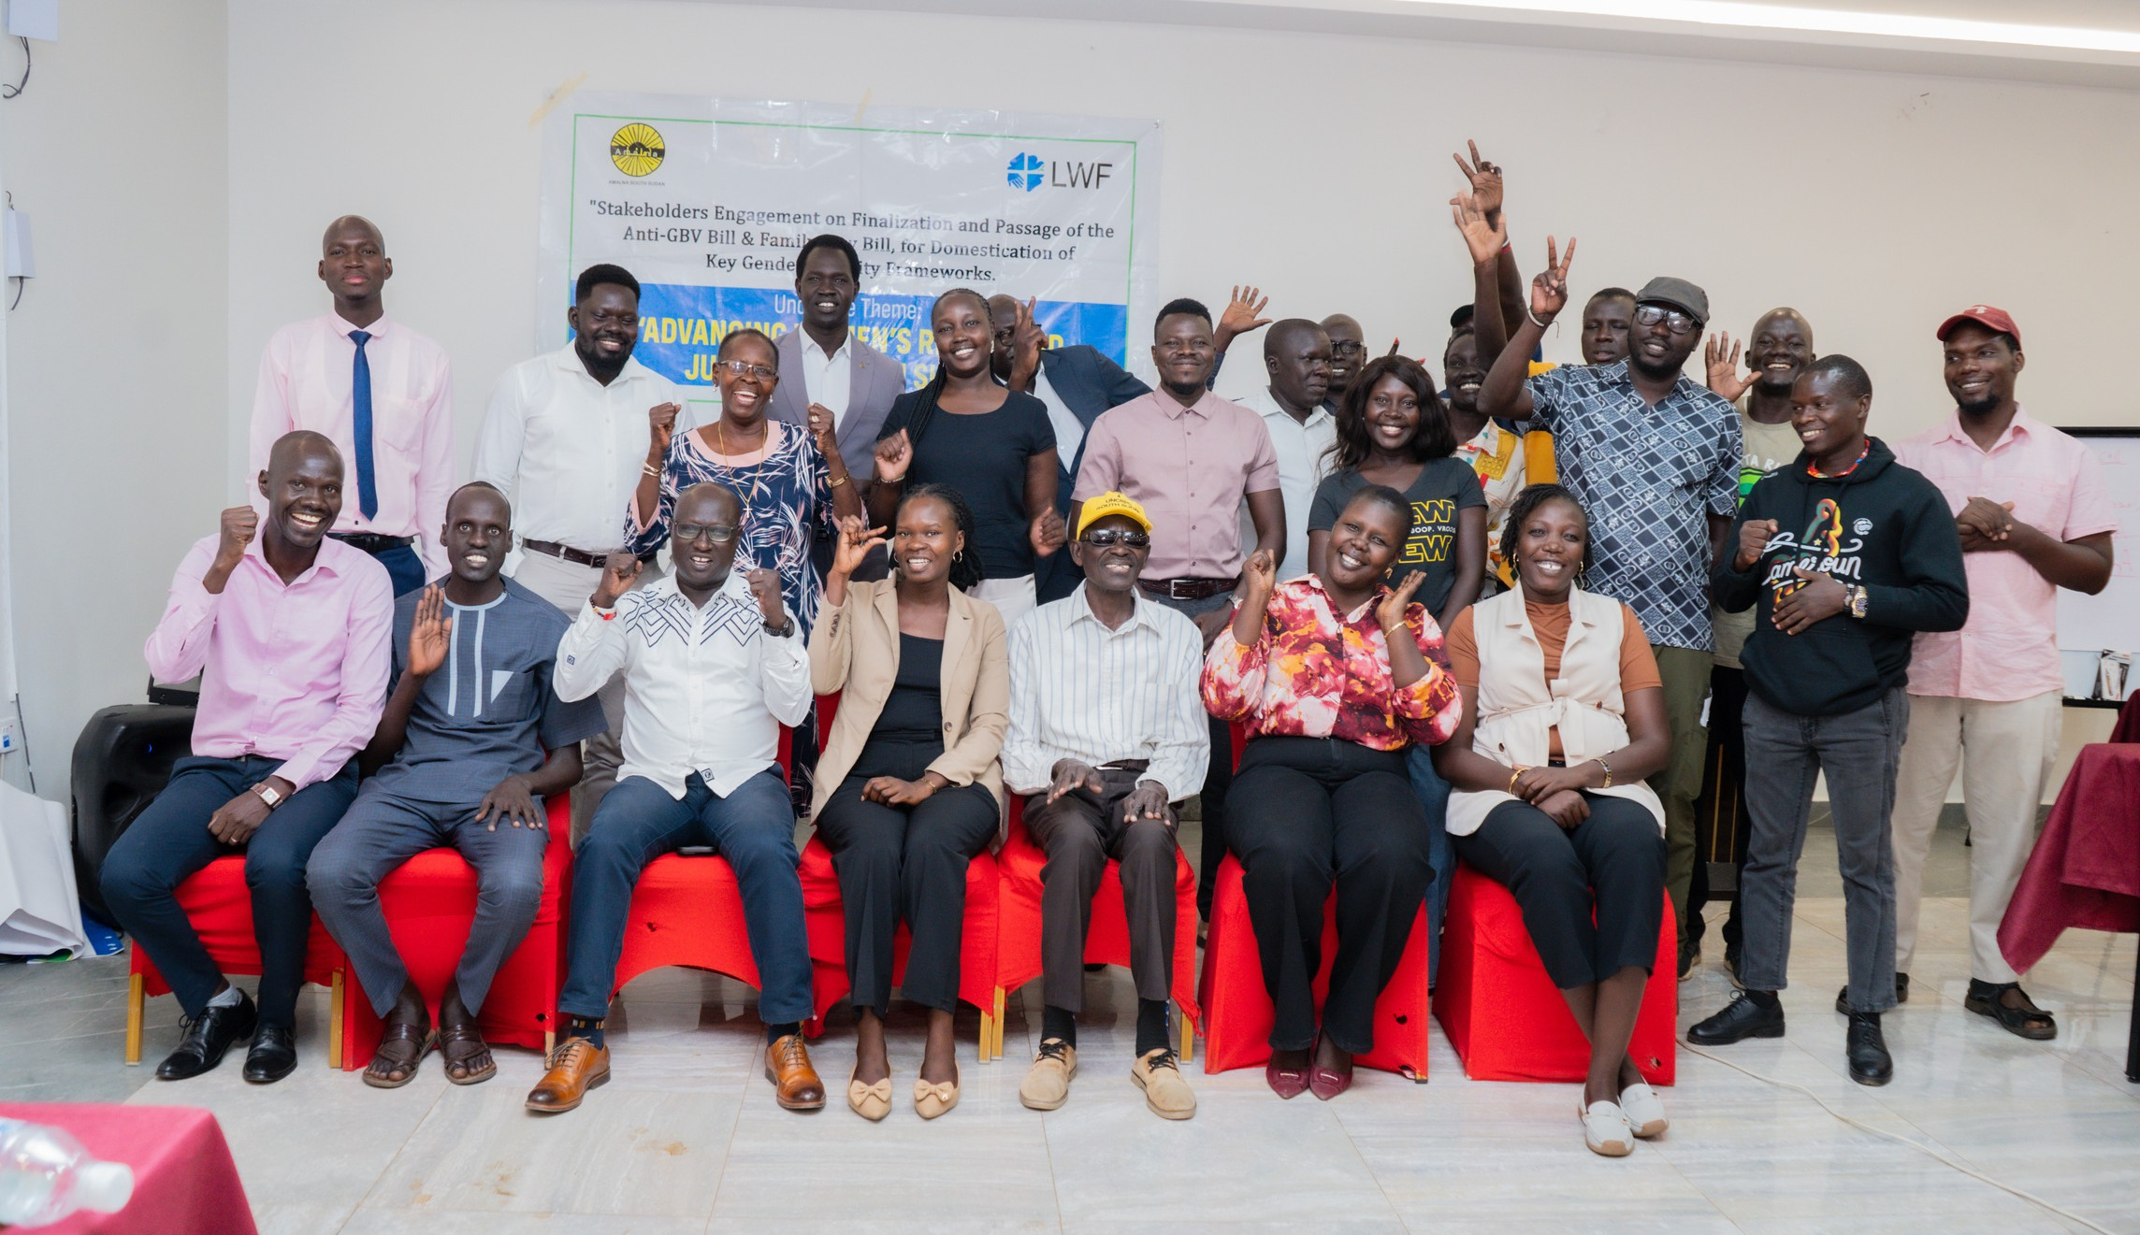
Monthly Newsletter February 2026

AMALNA SOUTH SUDAN CONVENED STRATEGIC JOINT CSO LOBBY AND ADVOCACY MEETING

CSOs, networks, Coalitions youth, women, PWD representatives, South Sudan Women in the Security Sector, media, female Journalist Network at the Strategic CSO Lobby and Advocacy Meeting at Yam Hotel, 19 Feb, 2026

Juba, 19th February 2026 – AMALNA South Sudan convened a one-day workshop at YAM Hotel in Juba, marking the second Strategic Joint CSOs Lobby and Advocacy Meeting under the Advancing Gender Justice through Inclusive Legal Engagement (AGILE) Project, funded by the Lutheran World Federation (LWF).

The primary objective of the meeting was to strengthen coordinated civil society lobbying and advocacy efforts around key gender justice legal reforms, particularly the Anti-GBV Bill and the Family Law Bill in South Sudan. AMALNA aimed to build a unified and strategic civil society platform capable of engaging policymakers with clear, evidence-based, and people-centered advocacy messages.
The workshop brought together representatives from civil society organizations, networks, youth groups, women’s associations, persons with disabilities (PWDs), South Sudan Women in the Security Sector, media practitioners, and the Female Journalist Network. Participants reflected on Quarter One achievements, identified lessons learned, and refined joint strategies to accelerate the enactment of gender-responsive laws.

The impact of the meeting is significant for the public. By fostering a coordinated and unified civil society voice, he engagement strengthened collective advocacy efforts to push for stronger legal protections against gender-based violence and clearer family law safeguards.

5

Participants agreed to develop a joint Communiqué/Position Paper outlining shared advocacy priorities and key reform messages. A dissemination committee will also be established to ensure that these recommendations reach policymakers, the media, and communities across the country.

Through this coordinated approach, AMALNA South Sudan is helping to ensure that the voices of women, youth, persons with disabilities, and grassroots organizations are reflected in national legal reform processes.
The initiative contributes to more inclusive policymaking, stronger accountability, and improved legal protections for women and girls.

The meeting reaffirmed AMALNA South Sudan’s commitment to advancing gender justice, strengthening civil society collaboration, and promoting reforms that respond to the real needs of citizens.
Monthly Newsletter February 2026
AMALNA SOUTH SUDAN CONVENED STRATEGIC JOINT CSO
LOBBY AND ADVOCACY MEETING

6

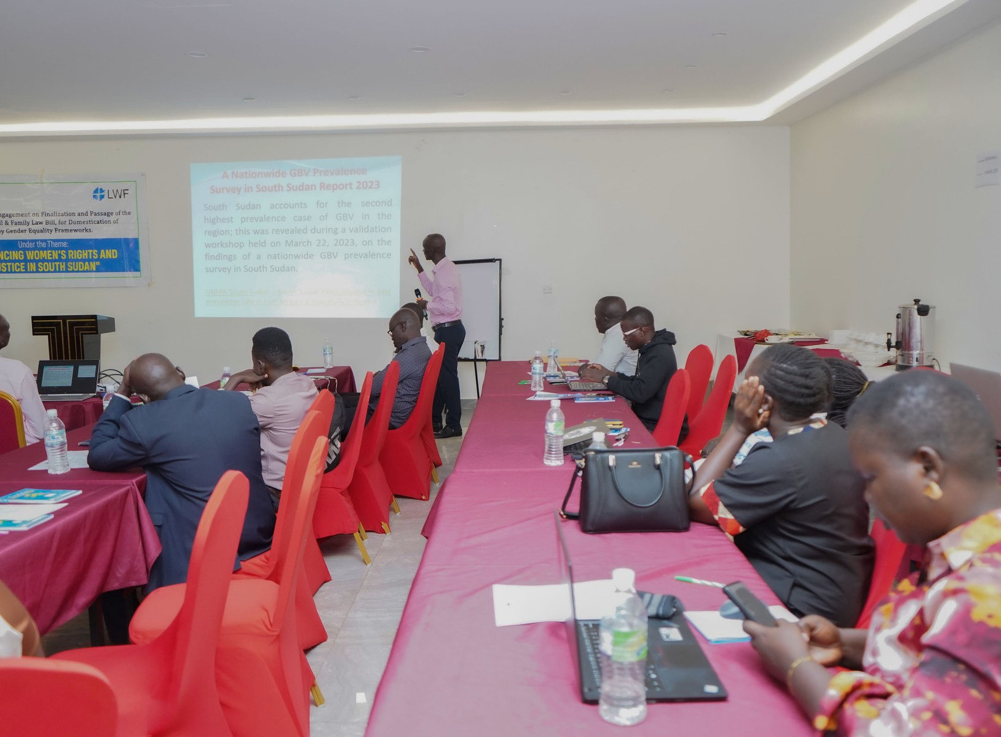

Monthly Newsletter February 2026

ANNOUNCEMENT FOR UPCOMING EVENTS

AMALNA South Sudan is excited to announce several activities this March under the Advancing Gender Justice through Inclusive Legal Engagement (AGILE) Project aimed at promoting awareness and advocacy on the Anti-GBV Bill.

Interactive Webinar
Join us online for an engaging session to discuss the Anti-Gender-Based Violence Bill, explore ways the public can participate in the legislative process, and hear insights from civil society representatives and other stakeholders. Stay tuned for the exact date and registration details.

Radio Talk Show on Eye Radio
Tune in to live discussions on gender justice, legal reforms, and how citizens can contribute to shaping laws that protect women, girls, and vulnerable communities. Listeners will have the opportunity to ask questions and share their views directly with experts.

Community Engagement & Awareness Activities
Throughout the month, AMALNA South Sudan will also conduct additional awareness and advocacy activities, including social media campaigns, community dialogues, and public engagement initiatives to encourage citizens to advocate for the passage of the Anti-GBV Bill.

These activities reflect AMALNA South Sudan’s commitment to inclusive advocacy, public awareness, and community participation in advancing legal protections for women and girls in South Sudan.

Follow our social media channels for updates on dates, times, and participation links.

Contact Details
Email: info@amalna-ss.org Phone: + (211) 924 178 748
https://www.amalna-ss.org/

Munuki 3rd Class Residential Area, Plot No.49 Block A 111, Bilpham Road Juba, Republic of South Sudan

Thematic Areas
Natural Resource Management Democracy and Governance Humanitarian Response
and Economic Empowerment Peace Building
Institutional Capacity Strengthening and Resource Mobilization

7
https://www.amalna-ss.org/

